# CS 255 System Design Document

## UML Diagrams

### UML Use Case Diagram

### This is a simple breakdown of the system in the form of a use case diagram.

### UML Activity Diagrams

These two diagrams represent the process of a standard user logging in, as well as how the user would schedule lessons.

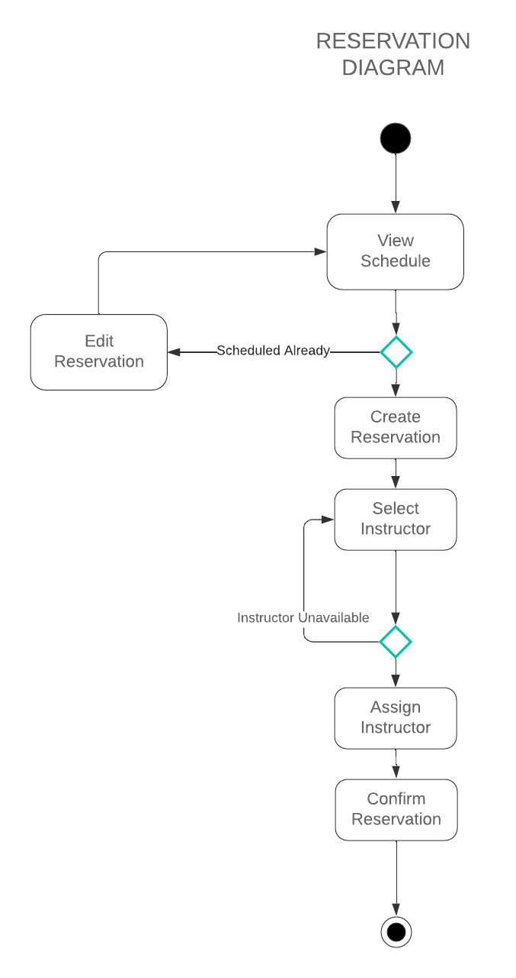

### UML Sequence Diagram

This is the process of the standard user logging in, but as a sequence diagram.

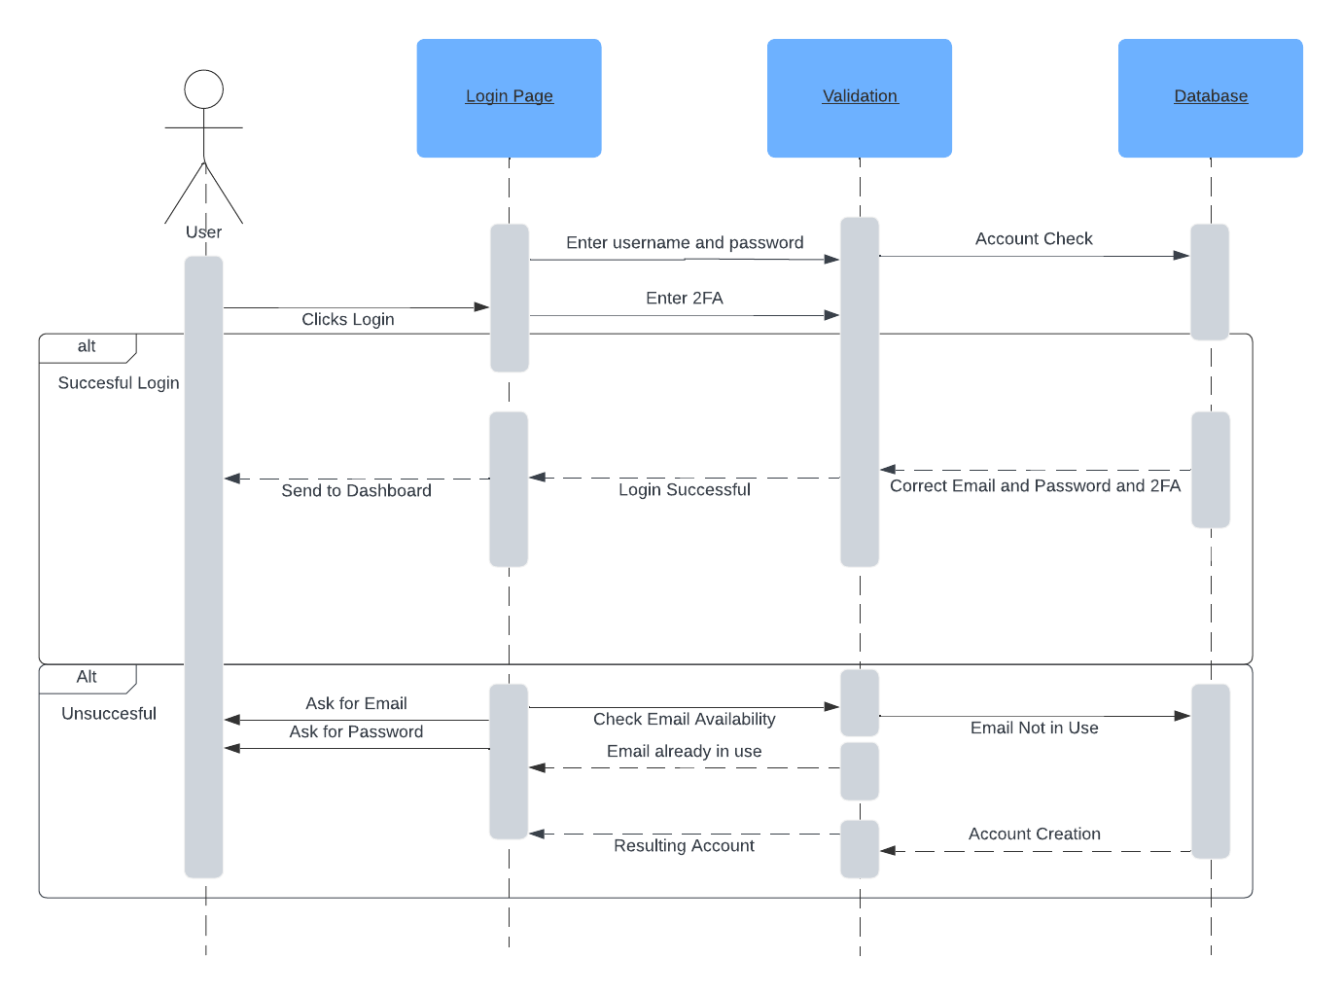

### UML Class Diagram

## Technical Requirements

The Requirements of this system would include:

* A proper 3rd party website to host the server.
* A proper computer/phone that can handle modern day web browsing.
* Continued access to the internet.
* A 3rd party partner to manage payment and accounts.